# **Name: Abdurrahman Qureshi**

# **Roll No: 242466**

Practical No: 6

Date Of Performance: 05/03/2025

Aim: Implement Linked State Routing Protocol in NS2.

Lab Objectives:

The objective of this lab is to implement the Link State (LS) Routing Protocol in NS2

and analyse its behaviour in dynamic network conditions, including link failure and

recovery.

Lab Outcomes:

This lab demonstrates the implementation of the Link State (LS) Routing Protocol in NS2, showcasing its ability to dynamically update routing tables in response to link failures and recovery. Through trace analysis and NAM visualization, students observe how LS efficiently recalculates routes to ensure continuous data transmission. The experiment highlights LS routing’s faster convergence and adaptability compared to Distance Vector. This enhances understanding of real-world dynamic routing mechanisms in networking.

CODE:

# Create a Simulator instance

set ns [new Simulator]

# Open Trace and NAM files

set tr [open ls.tr w]

$ns trace-all $tr

set nf [open ls.nam w]

$ns namtrace-all $nf

# Finish procedure

proc finish {} {

global ns tr nf

$ns flush-trace

close $tr

close $nf

exec nam ls.nam &

exit 0

}

# Create Nodes

set n0 [$ns node]

set n1 [$ns node]

set n2 [$ns node]

set n3 [$ns node]

# Create Duplex Links with DropTail queue

$ns duplex-link $n0 $n1 10Mb 10ms DropTail

$ns duplex-link $n1 $n3 10Mb 10ms DropTail

$ns duplex-link $n2 $n1 10Mb 10ms DropTail

# Set Link Orientations

$ns duplex-link-op $n0 $n1 orient right-down

$ns duplex-link-op $n1 $n3 orient right

$ns duplex-link-op $n2 $n1 orient right-up

# Attach TCP Agent and FTP

set tcp [new Agent/TCP]

$ns attach-agent $n0 $tcp

set sink [new Agent/TCPSink]

$ns attach-agent $n3 $sink

$ns connect $tcp $sink

# Create FTP application

set ftp [new Application/FTP]

$ftp attach-agent $tcp

# Attach UDP Agent and CBR Traffic

set udp [new Agent/UDP]

$ns attach-agent $n2 $udp

set null [new Agent/Null]

$ns attach-agent $n3 $null

$ns connect $udp $null

# Create CBR application

set cbr [new Application/Traffic/CBR]

$cbr attach-agent $udp

# Enable Link State (LS) Routing Protocol

$ns rtproto LS

# Simulate Link Failure and Recovery

$ns rtmodel-at 1.0 down $n1 $n3

$ns rtmodel-at 2.0 up $n1 $n3

# Start Traffic

$ns at 0.0 "$ftp start"

$ns at 0.0 "$cbr start"

# Stop Simulation

$ns at 5.0 "finish"

# Run Simulation

$ns run

OUTPUT:

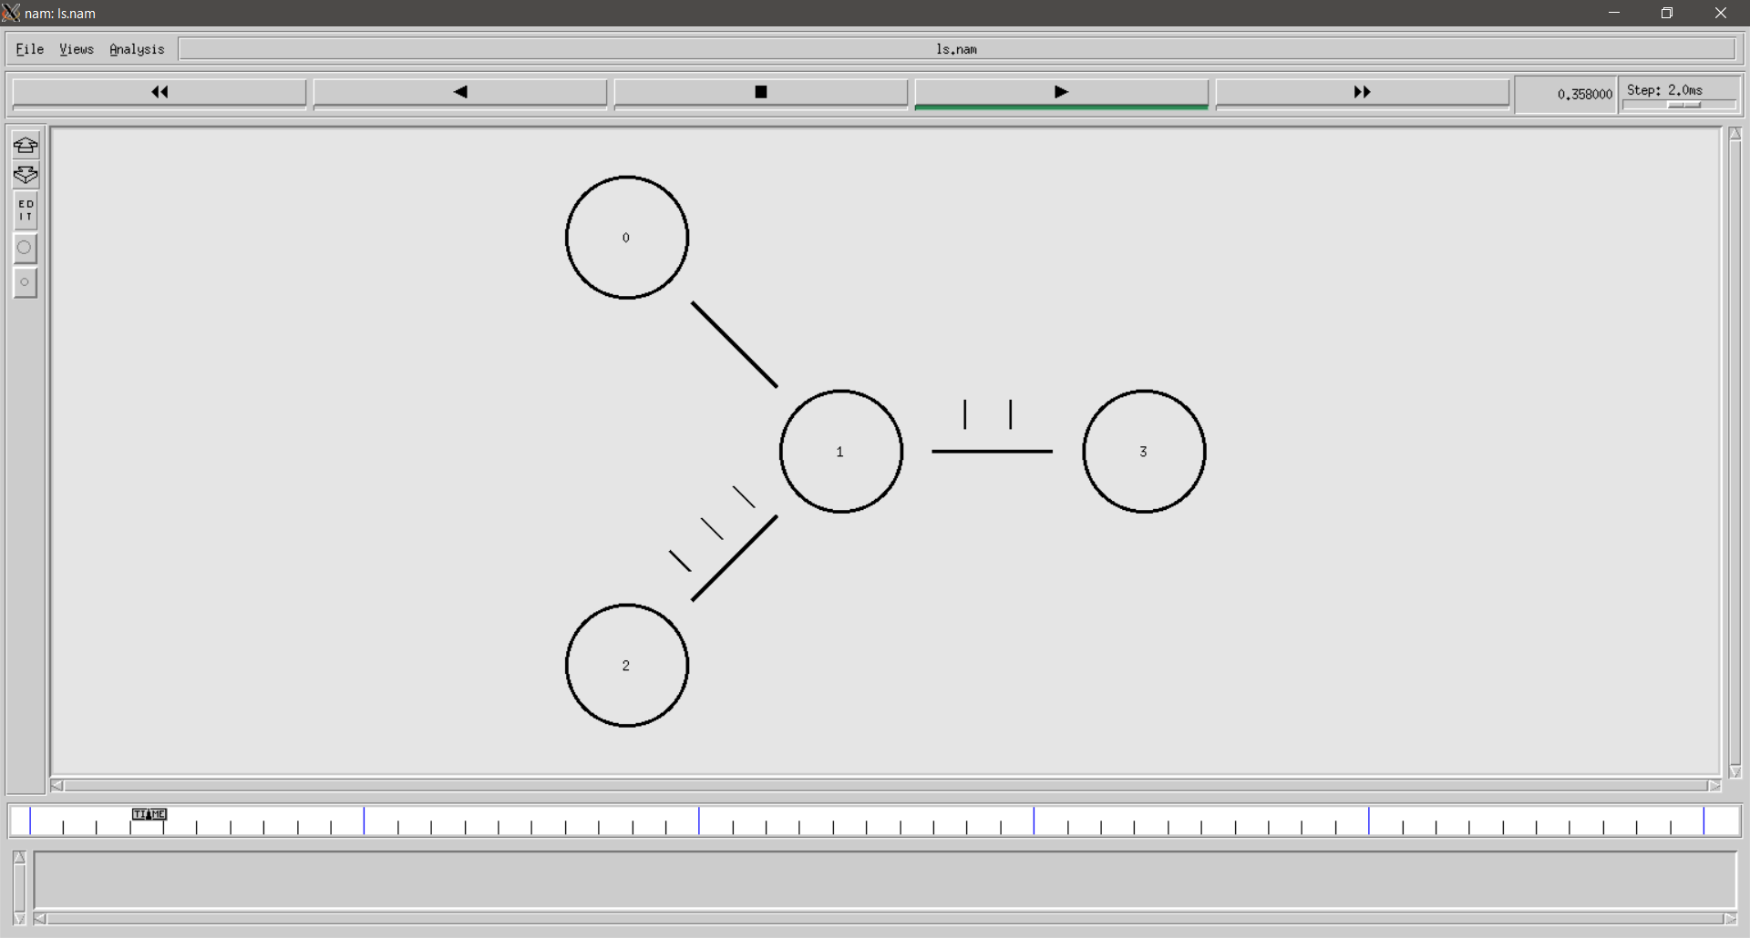

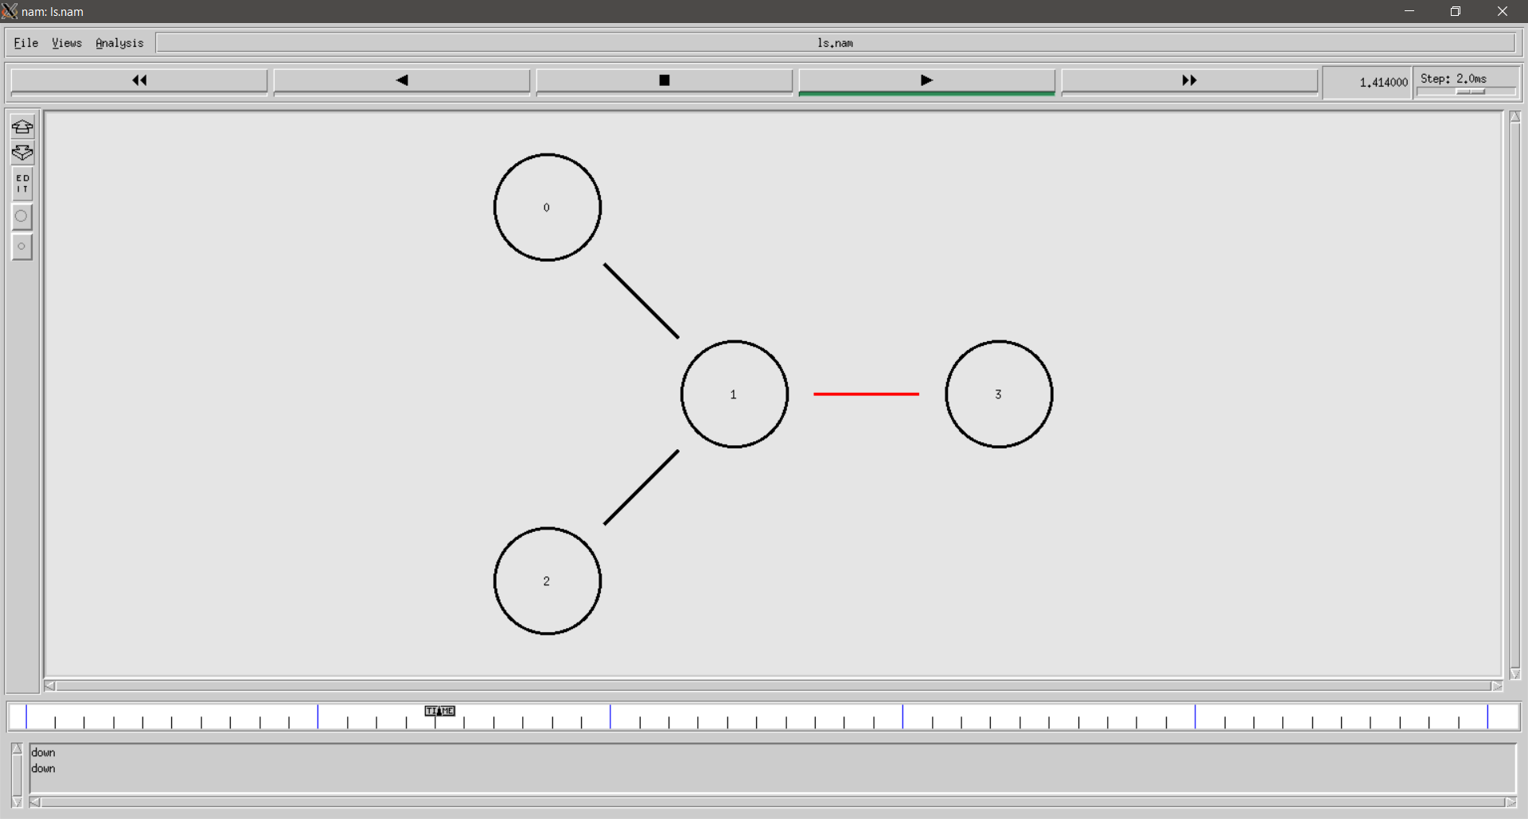

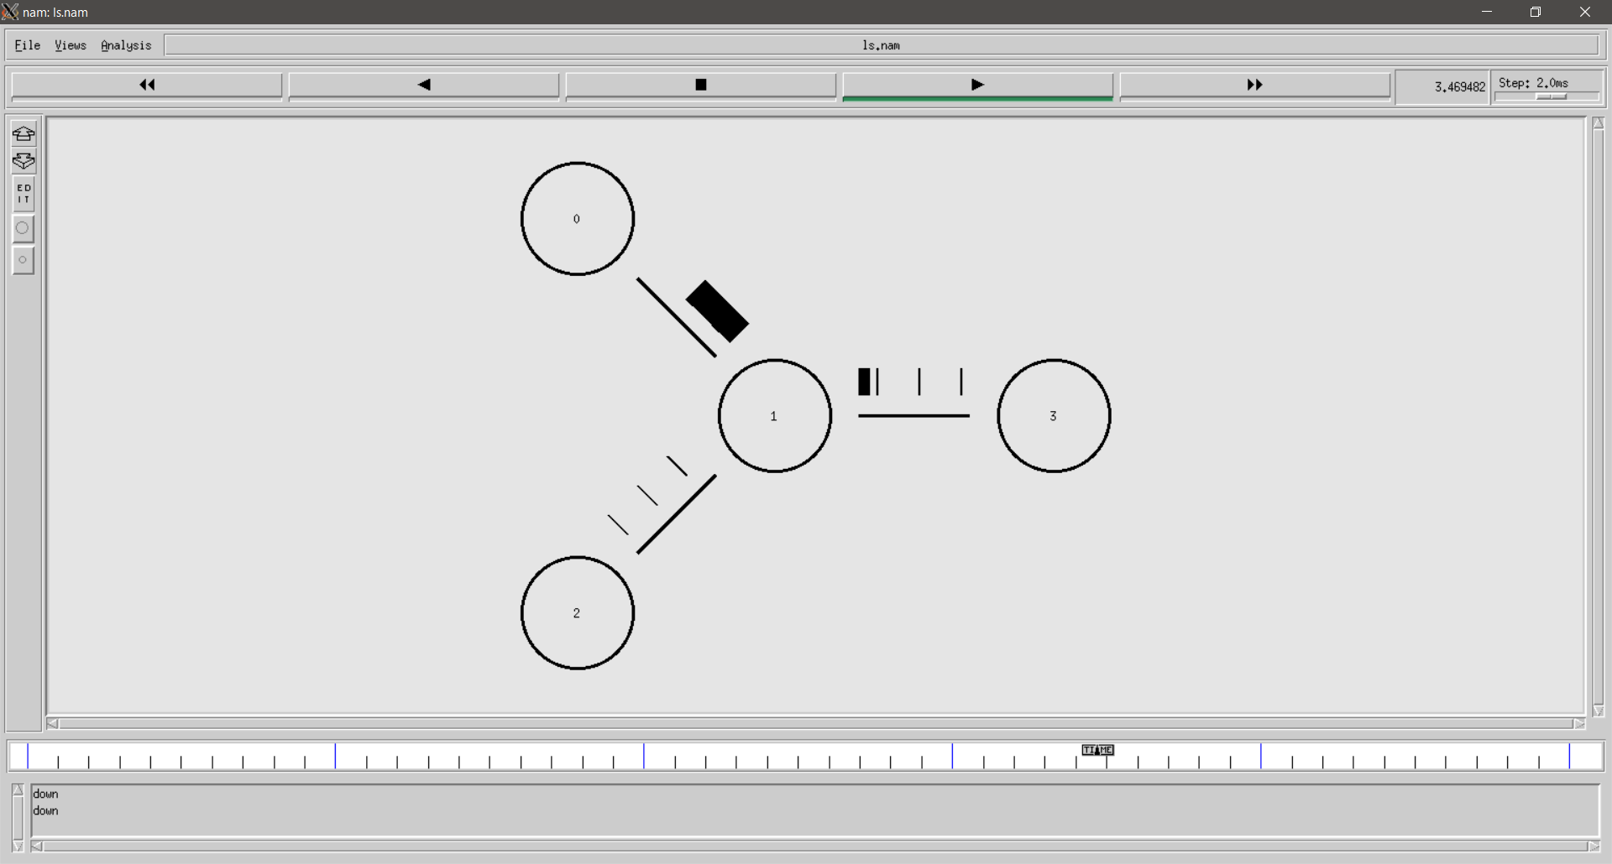

Conclusion:

This experiment successfully implements the Link State Routing Protocol in NS2 and demonstrates its ability to handle network changes dynamically. The LS protocol ensures faster convergence and efficient rerouting during link failures. Through trace files and NAM visualization, students can analyse how link-state updates propagate and improve network performance.

|  |  |  |  |  |  |
| --- | --- | --- | --- | --- | --- |
| Performance  (7M) | Journal  (3M) | Lab Ethics  (2M) | Attendance  (3M) | Total  (15M) | Faculty Signature |
|  |  |  |  |  |  |